

**N**ational **U**niversity of **C**omputer and **E**merging **S**ciences

ASSIGNMENT # 2

Submitted to: Miss Wafa Basit

Section: BSE-3C

Subject: Software Requirements Engineering

Course Code: SE2001

Project Members:

* Faraz Iftikhar 22L-7974
* Hamza Naveed 22L-7871
* Abdul Ahad 22L-7852
* Muhammad Ahmad 22L-7869

**OUTLINE**

1. Abstract
2. Project vision and concept
3. Vision and Concept
4. Key Stakeholders
5. Brief description of their roles
6. Elicitation Techniques
7. Response Rate
8. Analysis of the response rate
9. Summary of 28 responses
10. Personas
11. Scenario
12. Categories of Features
13. Core and enhancement feature categories
14. User Requirements
15. Business Requirements
16. Business Rules
17. Functional Requirements
18. Non-Functional Requirements
19. Constraints

**ABSTRACT**

In a community, it's important to have good ways of managing things so that everyone gets along and feels happy. This elicitation document talks about how we figured out what people in a housing community need in a management system. We used different methods like talking together, asking questions, doing surveys, and listening to people's stories to understand what they want. We also did online surveys in the community and got 28 responses, which we looked at closely. We found that people liked the idea of a system that's easy to use and practical. The document shows how we made sure to include everyone's ideas and keep things clear and friendly. It gives a strong plan for creating a management system that not only makes things like paperwork easier but also helps make the community livelier and more connected.

The **Vision** is to create a seamlessly integrated and user-friendly Society Management System that fosters transparent communication, efficient governance, and a sense of community. Our vision is to empower residents, committee members, and management personnel with a digital platform that not only simplifies daily tasks but also nurtures a vibrant and engaged living environment.

The concept is groundbreaking, especially considering the prevalent practices in housing societies where residents and management rely on fragmented chat applications like WhatsApp and Telegram for communication. Additionally, the persistence of paper-based challans for society maintenance bills and the lack of access for security guards to efficient communication platforms highlight significant inefficiencies in existing systems.

Unlike traditional housing societies websites that primarily focus on catering to potential real estate buyers and handle amenities reservations through physical visits, our innovative approach addresses these shortcomings comprehensively. By introducing a centralized web-based platform, we aim to bridge communication gaps, streamline maintenance bill processes, and empower security personnel with efficient tools. Residents will no longer have to visit the society premises for amenity reservations, enhancing convenience and accessibility. This **pioneering initiative** is set to revolutionize the way housing societies operate, fostering a sense of community, transparency, and security among residents.

**KEY STAKEHOLDERS**

The key stakeholders for this project include:

* Society Management Committee
* Residents and Homeowners
* Software Engineers and IT Team
* Third-party service providers (for payment processing, vehicle tracking, etc.)
* Media Team
* Security Guards
* Real State dealers
* Services Provider (amenity reservation services)

**ELICITATION TECHNIQUES**

While gathering vital insights and essential information for our software requirements engineering project, we systematically applied a range of effective elicitation techniques to ensure a comprehensive understanding of both user needs and project objectives. These techniques significantly enriched our understanding of our client's unique requirements, equipping us with a sharper vision for project execution. They played a pivotal role in guiding us through the project's intricacies, fostering confidence in our approach, and ensuring alignment with our client's expectations. As a result, we established a robust foundation for the project, laying the groundwork for a successful and client-centric solution. These elicitation techniques are as follows:

* Brainstorming
* Introspection
* Questionnaires
* User stories
* Group work
* Interviews

**Brainstorming:**

Through brainstorming sessions with the society owner and technical team for our software requirements engineering project, we derived valuable insights that led to the incorporation of essential features in our Society Management System. One notable feature that emerged is the "**Emergency Helplines**," providing residents with quick access to important contact numbers for immediate assistance. Another key feature that arose from these sessions is the "**Maintenance Bills**" functionality, allowing residents to efficiently manage and pay their maintenance bills online, contributing to a seamless and convenient experience within the community.

**Introspection:**

The inspiration for the "**Vehicle Monitoring System**" feature stemmed from the insights gained during introspection, where team members reflected on their experiences and drew inspiration from real-world solutions. Specifically, the idea was sparked by observing the effectiveness of motorway cameras. These cameras, widely utilized for monitoring and enhancing security on highways, served as a valuable reference point in envisioning a similar system tailored for the community's needs. By leveraging the concept of motorway cameras, we aimed to bring a heightened level of security and surveillance to the residential setting, ensuring a safer and more secure environment through the integration of the Vehicle Monitoring System within our Society Management System.

**Questionnaires:**

In our quest to comprehend user needs and preferences thoroughly, we leveraged questionnaires as a powerful elicitation technique. Crafting surveys using Google Forms, we presented a mix of open-ended and multiple-choice questions. These surveys were shared within the society's general chat group, resulting in a robust and constructive response from the community. Through careful analysis of the responses, a prominent feature emerged: the desire among users to have a feature facilitating the renting of their properties within society. The data-driven insights gathered through this questionnaire-driven approach played a decisive role in shaping our software requirements, ensuring that our system aligns closely with the expectations and preferences expressed by the community members. This user-driven feedback underscored the importance of incorporating practical and sought-after functionalities, such as the **property rental feature**, into our Society Management System.

**Interviews:**

In our software requirement gathering process, interviews served as a fundamental elicitation technique for gathering crucial insights and perspectives from key stakeholders, including society management committee members and potential end-users. This one-on-one group discussions allowed us to delve deep into their specific needs, challenges, and expectations. Here are some of the key questions we asked during the interviews:

* **Can you provide an overview of society’s management needs and challenges?**

This question helped us establish a foundation by understanding the broader context and challenges faced by the community.

* **What are the most common tasks or activities that residents and society management personnel perform regularly?**

We used this question to identify routine tasks and activities that the system should support.

* **How do residents currently receive information about society events, news, and important updates?**

After understanding current communication methods, we inferred the need for the feature of **society news updates.**

* **In what format are maintenance bills usually delivered to residents (e.g., paper bills, email, physical notices)?**

After asking the question about the typical format of maintenance bill delivery to residents, we inferred the need for the feature of an **online billing system.**

* **How do residents typically make payments for their maintenance bills?**

This question seeks to uncover the various payment methods and channels resident’s use.

* **How can the system enhance communication between residents and the society's management committee?**

After understanding current communication methods, we infer the need for **feedback submission mechanisms** to facilitate seamless and effective communication between residents and the management committee.

* **What security measures are currently in place to protect resident and society data?**

We explored existing security practices to ensure data protection.

* **How does the community currently engage residents in decision-making and community initiatives?**

After posing the question regarding the community's current methods for engaging residents in decision-making and community initiatives, we discerned the need for an **online voting system.**

* **What methods are in place for collecting resident feedback, suggestions, and complaints?**

Understanding current feedback mechanisms helped us to consider an **effective online feedback system.**

These interviews allowed us to gain a comprehensive understanding of stakeholder perspectives, needs, and requirements, serving as a critical foundation for the development of our Society Management System.

**Group Work:**

In the process of gathering software requirements for our society management project, we engaged in one-on-one group discussions and utilized voice chats with key stakeholders, including the Station Head of society (Col. Arshad), SDO (Mr. Shahid) and Electrical Management In charge (Mr. AbdulWahab) to identify pain points. These discussions led to the identification of crucial features, such as an **online billing system, feedback and complaint system, and online owner information system**. Furthermore, our development team employed various communication channels, including Google Meetings and in-person meetings, to further refine requirements by promoting idea generation, conflict resolution, and alignment with the community's unique needs. During these collaborative discussions, our group members introduced features, such as **amenity reservation and Molvi booking capabilities**, after in-depth conversations and brainstorming. This comprehensive and collaborative approach ensured that the resulting software effectively addresses the committee's challenges and objectives.

**User Stories:**

* As a user, I want to easily access contact information of other homeowners in the community to facilitate communication and interaction.
* As a user, I want to view a list of upcoming society events, including dates, times, and descriptions, to stay informed and plan my participation accordingly.
* As a user, I want the ability to view, manage, and pay my maintenance bills online. I should be able to see detailed billing information and payment history.
* As a user, I want to receive regular updates and news headlines about society-related matters to stay informed about important developments and announcements.
* As a user, I want to have access to a Complaint Box where I can submit my concerns or complaints for society management.
* As a user, I want the option to book Maulvi services for Nikah and Funeral arrangements, ensuring a convenient and organized process due to the critical nature of these events.
* As a user, I want an interactive map of the community that provides a visual layout of amenities, common areas, emergency exits and key locations to help me navigate society easily.
* As a user, I want the capability to reserve community facilities such as clubhouses, swimming pools, and event spaces for personal or group use.
* As a user, I want quick access to important contact numbers for immediate assistance during emergencies or security-related issues.
* As a user, I want to participate in digital community voting to have a say in important decisions and initiatives within society.
* As a user, I want to have access to a system that enhances security by tracking vehicles entering and exiting the society premises.
* As a user, I want the ability to explore property listings, manage property transactions (buying, selling, renting), and access property-related information within the community.
* As a user, I want to contribute to community initiatives and campaigns by making financial contributions through the system.
* As a user, I want a streamlined process for registering and tracking visitors to ensure security and transparency in visitor management.
* As a user, I want to provide suggestions, feedback, and comments about various aspects of the community through a user-friendly feedback system.

**RESPONSE RATE**

In our analysis of the response rate for the Society Management System project, we took a unique approach by sharing an online survey form discreetly within our society's general chat. This strategy resulted in 28 responses, each representing a valuable perspective from an actual resident. These responses serve as a direct conduit to the concerns, preferences, and expectations of our community, providing a rich source of information for our project.

These 28 responses encapsulate the voices of our residents, reflecting their desires and requirements. As we delve into data analysis, our goal is to unveil patterns, trends, and common themes among these responses. Beyond the numerical figures, our analysis will bring out qualitative insights that can effectively guide decision-making.

Through this commitment to transparency and community engagement, our analysis aims to present a concise yet comprehensive view of our society's expectations and demands, forming the foundation for a Society Management System that aligns seamlessly with our residents' aspirations and needs. Data analysis is shown below with the assistance of Pie charts:

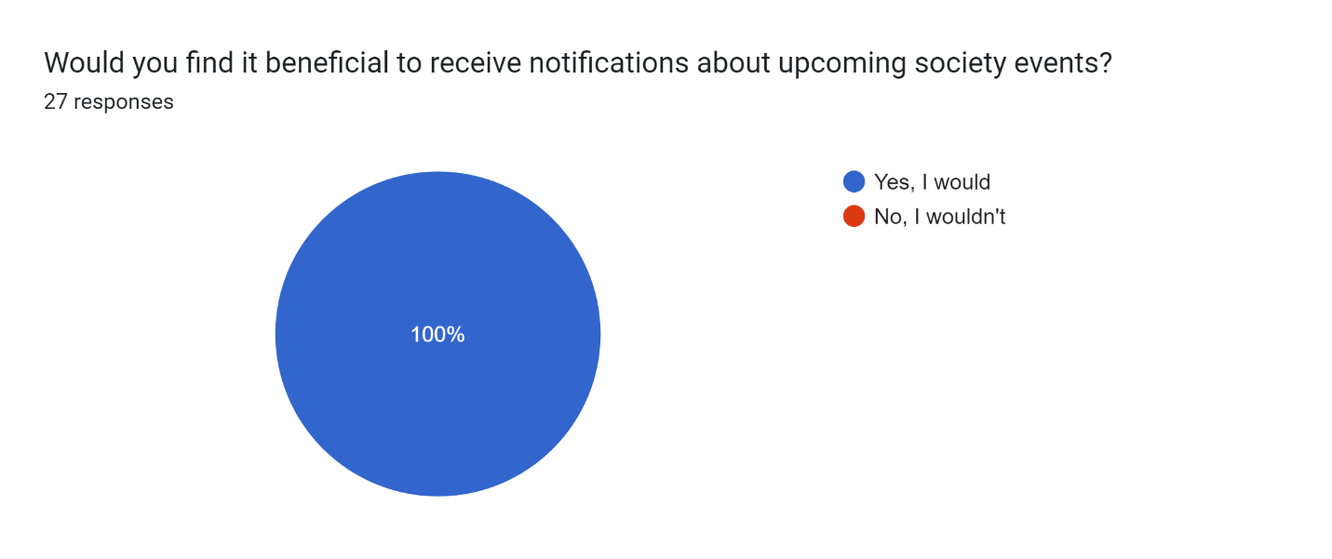

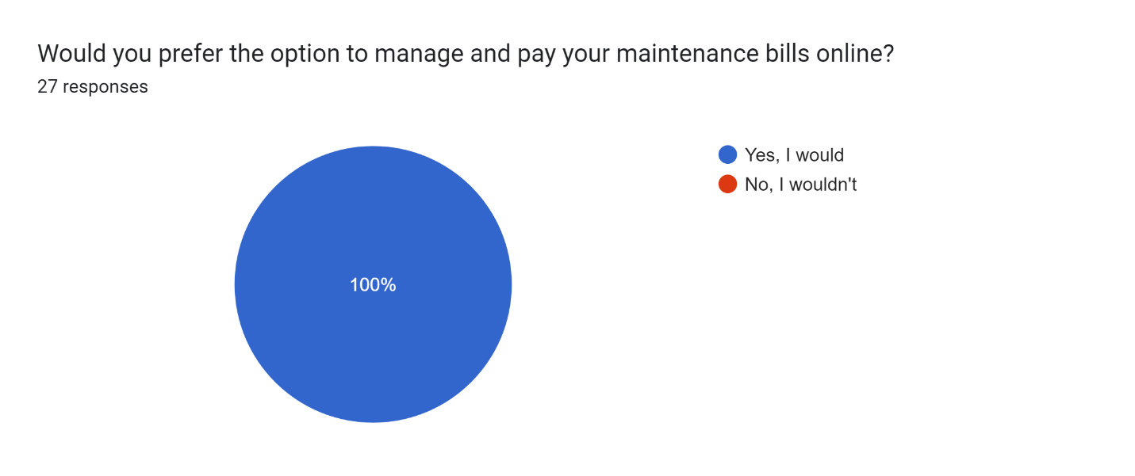

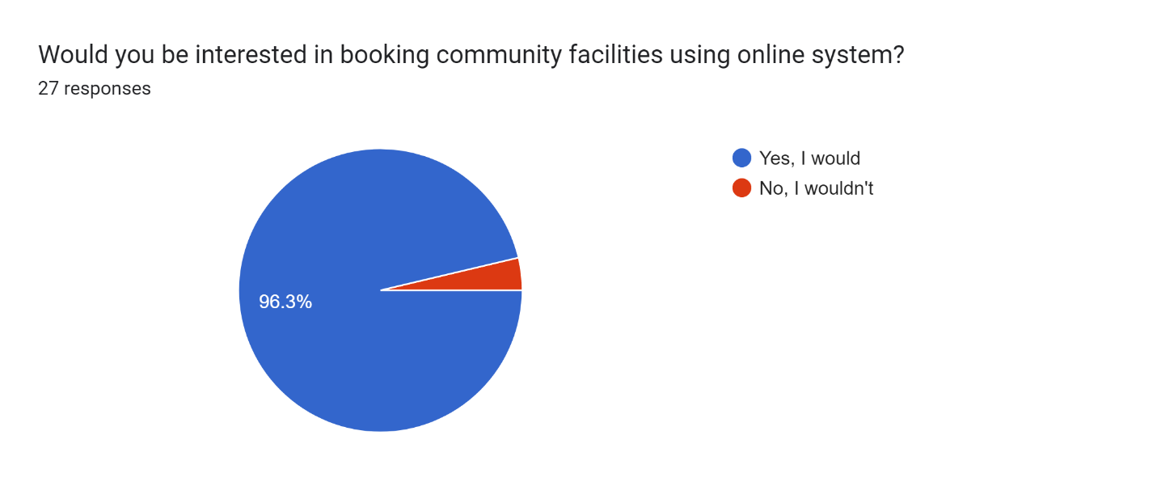 Forms response chart. Question title: Do you prefer having the option to post your properties for sale or rent within the society using the system?
. Number of responses: 27 responses. Forms response chart. Question title: How important is it for you to receive timely society news updates on a digital platform?
. Number of responses: 27 responses. Forms response chart. Question title: Would you like the option to submit your concerns online for a prompt resolution?
. Number of responses: 27 responses. Forms response chart. Question title: How essential do you think it is to have emergency contact numbers readily available online?
. Number of responses: 27 responses. Forms response chart. Question title: Are you interested in participating in digital community voting for decision-making purposes?
. Number of responses: 27 responses. Forms response chart. Question title: How often do you foresee yourself using the community website?
. Number of responses: 27 responses. Forms response chart. Question title: Would you prefer an online system for registering and tracking visitors within the community?
. Number of responses: 27 responses. Forms response chart. Question title: How tech-savvy do you consider yourself?
. Number of responses: 27 responses.

**PERSONAS**

**1. Homeowner Mr. Hameed:**

* Age: 35
* Occupation: IT Professional

**Goals:**

* Quickly access maintenance bills and make online payments.
* Stay updated on society events and participate in them.
* Lodge complaints and track their resolution.
* Use the website to book community amenities.
* Keep informed about property transactions within the community.

**2. Event Enthusiast Ms. Alina:**

* Age: 28
* Occupation: Event Planner

**Goals:**

* Stay updated on upcoming society events and RSVP for them.
* Access contact information for event planning purposes.
* Share event details with the community.
* Use amenity reservations for event-related bookings.

**3. Concerned Citizen Ms. Fatima:**

* Age: 45
* Occupation: Homemaker

**Goals:**

* Submit and track complaints and concerns for a better living environment.
* Access emergency helpline numbers for security.
* Participate in resident voting for community decisions.
* Provide feedback and suggestions for improvements.

**4. Safety-Conscious Mr. Abdul Wasay:**

* Age: 40
* Occupation: Security Professional

**Goals:**

* Use the vehicle monitoring system for enhanced security.
* Access emergency helpline numbers for quick response.
* Stay informed about society events, especially those related to safety.
* Provide feedback on security-related matters.

**5. Community Organizer Ms. Ayesha:**

* Age: 55
* Occupation: Retired Teacher

**Goals:**

* Organize and promote community campaigns.
* Use campaign contributions for fundraising.
* Stay informed about society news and events.
* Access emergency helpline numbers for community events.

**6. Visitor Manager Mr. Abdulwahab:**

* Age: 42
* Occupation: Security Guard

**Goals:**

* Use visitor management features to register and track visitors.
* Ensure the security and safety of the community.
* Access emergency helpline numbers for immediate assistance

**SCENERIO**

A resident of the housing society decides to book the community's swimming pool for a weekend gathering with friends. They log into the housing society website, navigate to the "Amenity Reservations" section, and select the swimming pool as their preferred amenity. After checking the availability for their desired date and time, they proceed to fill in the event details, indicating it's for a weekend pool party. They then review the booking terms and conditions, and upon agreement, they confirm the booking. Subsequently, they receive instant confirmation on the website, reassuring them that the pool is reserved for their event. The resident completes their tasks by logging out of the website, looking forward to their fun-filled gathering at the community pool.

**CATEROGY OF FEATURES**

1. Core Features:

* **House Owner Contacts** provide access to homeowner contact information.
* **Upcoming Events** that keep residents informed about society events.
* **Maintenance Bills** that enable residents to manage and pay their maintenance bills
* online.
* **News Headlines** that deliver the latest society news updates.
* The **Complaint Box** allows residents to submit their concerns for prompt resolution.
* The **Society Map** offers an interactive layout of the community.
* **Emergency Helplines** that provide important contact numbers for immediate assistance.

2. Enhancement Features:

* **Maulvi Booking facilitates** the arrangement of Nikah and Funeral services.
* **Amenity Reservations** that let residents book community facilities.
* **Resident Voting** that allows participation in digital community voting.
* The **Vehicle Monitoring system** enhances security by tracking vehicles.
* **Property Transactions** that support buying, selling, and renting properties within the
* community.
* **Campaign Contributions** that enable residents to support community initiatives.
* **Visitor Management** streamlines the registration and tracking of visitors.
* The **Feedback System** that collects resident suggestions and feedback

**USER REQUIREMENTS**

1. The system shall enable residents to view the contact information of other house owners.
2. The system shall provide a list of all upcoming events in society.
3. The system shall allow residents to access and view their maintenance bills online through the app.
4. The system shall facilitate residents in booking Maulvi services for Nikah and Funeral ceremonies through the app.
5. The system shall categorize complaints and assign them to the appropriate person for resolution.
6. The system shall enable residents to make bookings for facilities and provide a payment option through the app.
7. The system shall provide a list of important contact numbers for emergency services.
8. The system shall allow residents to participate in digital community voting through the app.
9. The system shall provide a list of all available properties for sale and rent within the society, including information such as price and location.
10. The system shall enable residents to support community initiatives by making campaign contributions through the app.
11. The system shall allow residents to submit suggestions and feedback through the app.

**BUSINESS REQUIREMENTS**

The key business requirements of the Society Management System are as follows:

1. The system shall streamline society operations and administrative tasks, thereby reducing manual effort and minimizing errors.
2. The system shall save the cost of paper challan/stationary by generating E-challan.
3. The implementation of a car monitoring system in the system shall result in cost savings by reducing the need for security guards.
4. The system shall ensure transparent tracking and management of community financial transactions to maintain accountability.

**BUSINESS RULES**

* Only registered homeowners should have access to homeowner contact information.
* Property transactions will only be approved and processed if all outstanding dues for the respective property are cleared.
* An incremental penalty of 3% will be applied to outstanding dues every 10 days, starting from the due date.
* Feedback submissions are reviewed by the relevant department or responsible party within 3 business days.

**FUNCTIONAL REQUIREMENTS**

1. The system shall provide a searchable directory of homeowner contact information.
2. Users shall be able to update their contact information through their profiles.
3. The system shall display a list of upcoming society events on the resident's dashboard.
4. Residents shall have the option to view event details.
5. Event organizers shall be able to add, edit, and delete event information.
6. The system shall generate electronic maintenance bills for each resident.
7. Residents shall receive email notifications when new bills are available.
8. Online payment shall be facilitated, allowing residents to pay their bills securely.
9. Residents shall have the option to submit complaints and concerns through a designated interface.
10. Management shall have access to review and assign complaints for resolution.
11. Residents shall be able to request Nikah and Funeral services through the system.
12. The system shall display an interactive map of the community layout.
13. Residents shall have the option to book community amenities (e.g., clubhouses, gyms) for specific dates and times.
14. The system shall provide a list of important contact numbers for emergency assistance.
15. The map shall support zooming and panning for detailed exploration.
16. The system shall support digital community voting on various issues and decisions.
17. Vote results shall be recorded and accessible to authorized users.
18. The system shall track and record the entry and exit of vehicles within the community.
19. Authorized personnel shall have access to vehicle logs and history.
20. The system shall allow residents to list, buy, sell, or rent properties within the community.
21. Property listings shall include details such as price, photos, and descriptions.
22. The system shall provide a platform for residents to contribute to community initiatives and campaigns.
23. The system shall streamline the registration and tracking of visitors to the community.
24. Residents shall be able to pre-register guests and vendors.
25. Admins shall review and address resident feedback as appropriate.

**Non-Functional Requirements**

1. The system shall provide quick access to homeowner contact information, with a response time of no more than 5 seconds.
2. Homeowner contact information shall be stored securely and accessible only to authorized users.
3. **The system shall be able to handle a minimum of 10,000 homeowner profiles without significant performance degradation.**
4. **Event information shall be available 24/7, with real-time updates for event changes or cancellations.**
5. **The system shall load event listings within 5 second of user request.**
6. The online bill payment system shall be available and operational 99.9% of the time.
7. All online payment transactions shall be encrypted and comply with industry-standard security protocols.
8. **The system shall accommodate concurrent bill payments by at least 500 residents without performance degradation.**
9. **Society Events shall be updated in real-time or at a frequency not exceeding 15 minutes.**
10. Complaint data shall be stored securely and accessible only to authorized personnel.
11. The system shall maintain accurate availability calendars for Maulvi services.
12. The system shall handle booking requests and updates without delays exceeding 2 seconds.
13. The Society Map shall load within 3 seconds and support smooth navigation and zooming.
14. Residents shall receive immediate confirmation upon successful amenity reservations.
15. **The list of emergency contact numbers shall be available 24/7.**
16. Emergency contact information shall be backed up and accessible even in case of system failures.
17. The resident voting system shall use robust authentication and encryption to ensure the integrity of votes.
18. **The system shall support a minimum of 5,000 concurrent votes without performance degradation.**
19. The vehicle tracking system shall provide real-time updates on vehicle locations with a delay of no more than 10 seconds.
20. **The system shall acknowledge resident complaint submissions immediately and provide a timeframe for resolution or follow-up.**

**CONSTRAINTS**

1. **Budget Constraints:**

The project has a predefined budget, and any cost overruns must be minimized. The development team must work within these budgetary constraints to ensure financial viability.

1. **Time Constraints**:

The project has a specified timeline for completion, and any delays can have negative implications. The development team must adhere to the project schedule and milestones.

1. **Technical Constraints**:

The system must be developed using specific technologies, frameworks, or platforms as mandated by the project stakeholders or technical requirements. The team must work within these technical constraints.

1. **Data Security and Privacy Regulations:**

The system will handle sensitive information, including homeowner contact details and financial data for maintenance bills. Compliance with data security and privacy regulations (e.g., GDPR, HIPAA) is critical, and measures must be taken to protect this information.

1. **Third-party Integration Limitations:**

The integration of third-party services for features like payment processing, vehicle tracking, and others may have limitations or dependencies. The compatibility and reliability of these third-party services must be considered.

1. **Internet Connectivity:**

The system relies on internet connectivity, and any disruption in internet services could affect its functionality. Redundancy and backup plans should be in place to mitigate this risk.

The link to the google forms is given below:

[Questioner](https://docs.google.com/forms/d/e/1FAIpQLSeAtYh9yawu3_nZNmW-36AilianVgQg4qUcZCfQ2pjRC5i0mA/viewform?usp=sf_link)

1. **The system shall be able to handle a minimum of 10,000 homeowner profiles without significant performance degradation.**
2. **Event information shall be available 24/7, with real-time updates for event changes or cancellations.**
3. **The system shall load event listings within 5 second of user request.**
4. **The bill status shall be updated within 1 hour of bill payment.**
5. **The system shall accommodate concurrent bill payments by at least 500 residents without performance degradation.**
6. **Society Events shall be updated in real-time or at a frequency not exceeding 15 minutes.**
7. **The list of emergency contact numbers shall be available 24/7.**
8. **The system shall support a minimum of 5,000 concurrent votes without performance degradation.**
9. **The system shall acknowledge resident complaint submissions immediately and provide a timeframe for resolution or follow-up.**